SOWIT Video Series – “A Bird in the Hand is Worth Two in the Bush”
(Video link: www.edb.gov.hk/sowit_bush)

Lesson Plan
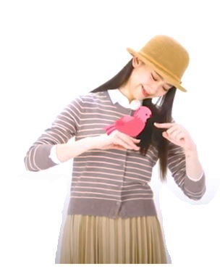

A bird in the hand is
worth two in the bush.

Suggested Levels
Upper Primary/Junior Secondary
Summary of the Learning Task
Students watch the SOWIT video “A Bird in the Hand is Worth Two in the Bush”, which is about a shepherd who realised that he should not risk losing the things he had already had by trying to get something that he thought might be better. They are then guided to understand the meaning of the saying “A bird in the hand is worth two in the bush”, learn about the related positive values and attitudes (e.g. be grateful, cherish what we have), and write a reflection on their personal experience.

Learning Objectives
Content
- To understand the meaning of the saying “A bird in the hand is worth two in the bush.” through a story presented in the context of a video

Language
- To explore the story elements of the video (e.g. characters, setting, change, moral)
- To make comparison using
- a graphic organiser (i.e. a Venn diagram)
- the language structure:
“No matter how (adjective) noun(phrase) may seem,
it is not as (adjective) as noun(phrase)!”

Values and Attitudes
- To cultivate positive values and attitudes (e.g. be grateful, cherish what we have)

Sharing Learning Intentions
1. Introduce the objectives of the learning activities.

Pre-viewing
Part A: Making Predictions about the Story
- Refer students to Activity Sheet: Part A.
- Show students the pictures below, which are captured from the SOWIT video “A Bird in the Hand is Worth Two in the Bush”:
Picture A: The oasis
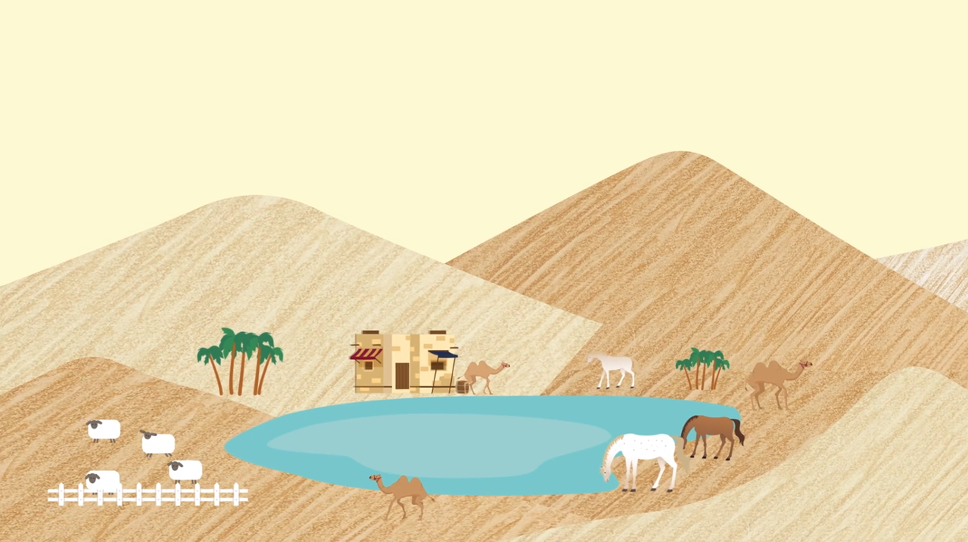
Picture B: The mirage
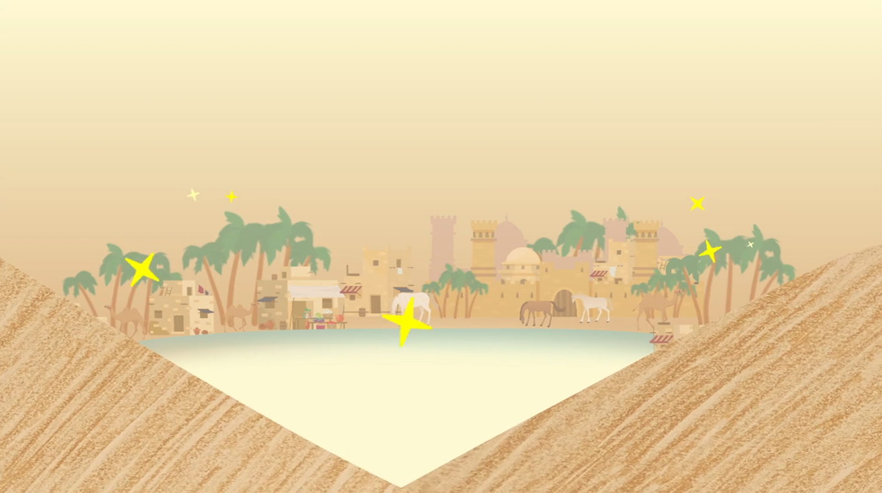

- Guide students to compare the setting of the two pictures by drawing their attention to the similarities and differences between the two places.
- Discuss with students their observations and invite them to share with the class where they would prefer to stay out of these two places.

Viewing
Part B: Understanding the Story Elements
- Refer students to Activity Sheet: Part B.
- Introduce the story elements (i.e. characters, setting, change, moral) before watching the video and instruct students to note down some key points for each element while watching the video.
- Play the video “A Bird in the Hand is Worth Two in the Bush”.
- Discuss with students the story elements of the video.
- Play the video again whenever necessary.
Post-viewing
Part C: Following the Development of the Story
- Refer students to Activity Sheet: Part C.
- Guide students to follow the development of ideas by drawing their attention to
- the setting of the sequence of events in the story; and
- the change in the shepherd’s life.
- Discuss with students whether they would share the same idea as the shepherd after seeing the mirage.
Part D: Characterisation
- Refer students to Activity Sheet: Part D.
- Guide students to analyse the emotional change of the main character (i.e. the shepherd) by drawing their attention to
- the shepherd’s feelings at the beginning, in the middle and at the end of the story; and
- the reasons for the change in the shepherd’s feelings.
- Play the video again whenever necessary.
Part E: Understanding the Saying of Wisdom
- Refer students to Activity Sheet: Part E.
- Revisit the meaning of the saying “A bird in the hand is worth two in the bush.” with students (i.e. You should not risk losing something you have already had by trying to get something you think might be better, or you might end up with nothing).
- Draw students’ attention to the communicative function and language structure of the sentence “No matter how great something faraway may seem, it is not as real as what you’ve already had!”:
- Communicative function
To compare
- Language structure
“No matter how (adjective) noun(phrase) may seem,
it is not as (adjective) as noun(phrase)!”
- Ask students to reflect on their personal experience and write a reflection on the video “A Bird in the Hand is Worth Two in the Bush”.

SOWIT Video Series – “A Bird in the Hand is Worth Two in the Bush”
Activity Sheets

(Pre-viewing)
Part A: Making Predictions about the Story

- Study the pictures below, which are captured from the SOWIT video “A Bird in the Hand is Worth Two in the Bush”.

Picture A | Picture B

- Compare Picture A with Picture B.

- Where did the story take place?
- What can you see in the pictures?

Write down your answers in the Venn diagram on the following page.

Picture B
Picture A

Differences
Differences
Similarities

- Which place do you want to stay at? Explain your answer.

__________________________________________________________________________________________________________

__________________________________________________________________________________________________________

(Viewing)

Part B: Understanding the Story Elements

- Watch the video and complete the story elements below:
(b)

- e.g. A shepherd and a camel

(c)

(d)

Story Elements
(Post-viewing)

Part C: Following the Development of the Story

- Study the pictures below, which show the setting of the sequence of events in the story.
Picture C
Picture B
Picture A

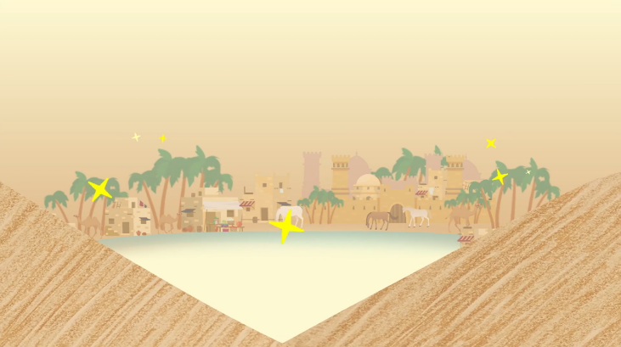
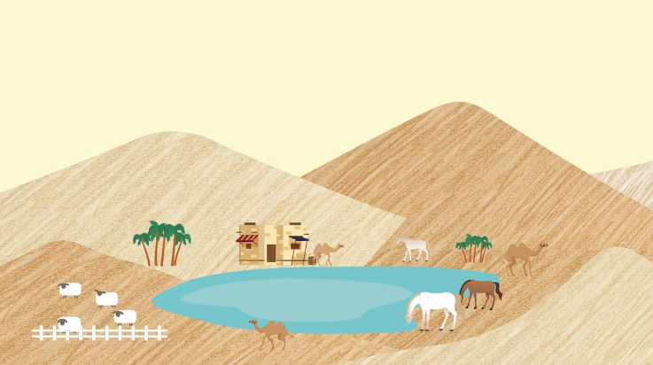
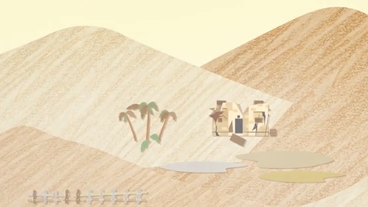

 | Picture A | Picture B | Picture C
- What were they? | An oasis
- Describe these places.
- What had happened to these places?

- Compare the life of the shepherd at the beginning of the story and at the end of the story.

End
Beginning

- Why did the shepherd leave the oasis?

_____________________________________________________________________________________________________

- If you were the shepherd, what would you do when you saw the mirage?

_____________________________________________________________________________________________________

Part D: Characterisation

- Analyse the shepherd’s emotional change in the story by completing the chart below:

End
Beginning
Middle
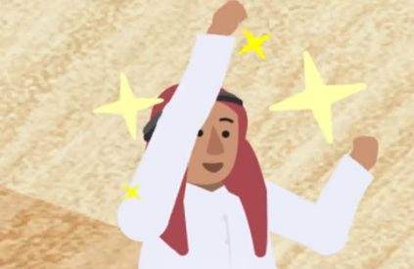
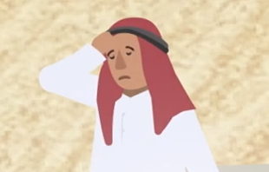
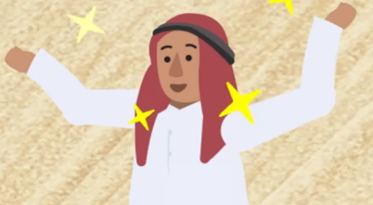

- Feeling
- Feeling
- Feeling

- Reason(s)
- Reason(s)
- Reason(s)

Part E: Understanding the Saying of Wisdom

- What is the message conveyed by the story?

________________________________________________________________
________________________________________________________________

- What is the meaning of the saying “A bird in the hand is worth two in the bush”?

________________________________________________________________
________________________________________________________________

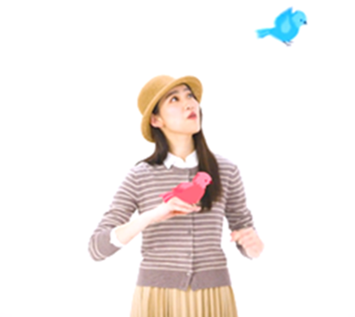
No matter how great
something faraway may seem,
it is not as real as
what you’ve already had!

Study the language structure of the sentence in the speech bubble above and write down your idea in the space below:

No matter how great something faraway may seem,
(a)[ ](b)[ noun(phrase) ]

it is not as real as what you’ve already had!
(c)[ ] (d)[ ]

- What is the use of this language structure?

____________________________________________________________

- In about 150 words, share your personal experience and write a reflection on “A bird in the hand is worth two in the bush”. You may include the following details in your work:

Title
A Bird in the Hand is Worth Two in the Bush

No matter how ________ _____________________ may seem,
Opening

it is not as __________ as ___________________!

Describe the event.

SOWIT Video Series – “A Bird in the Hand is Worth Two in the Bush”
What was the change/challenge?
Closing
Body
What have you learnt from the experience?
What happened in the end?
Activity Sheets (Suggested Answers)

Part A: Making Predictions about the Story
1(a) | 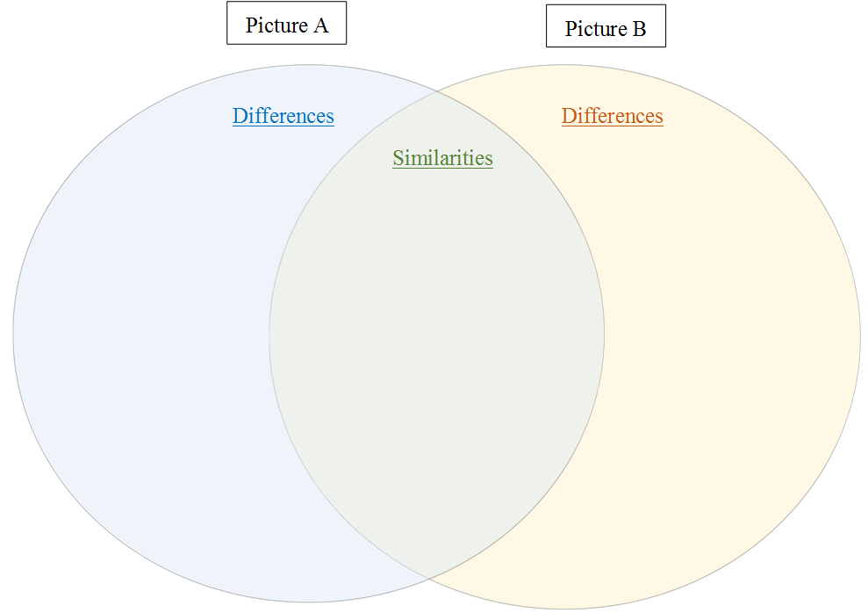  Some horses/ some camels  A desert/a lake/  a pond/near the hills  More trees/ some houses/ some buildings  (Accept any reasonable answers.)  (Accept any reasonable answers.)  (Accept any reasonable answers.)  Some sheep/ some trees/ a house
1(b) | Accept any reasonable answers.

Part B: Understanding the Story Elements
1(a) | A shepherd and a camel (given)
1(b) | A desert
1(c) | The shepherd saw a mirage in the distance. He thought he would get a better life out there.
1(d) | Cherish what you have now or you will lose more than you gain.

Part C: Following the Development of the Story
1. | Picture A Picture B Picture C  - What were they? An oasis (given) A mirage A ruin  - Describe these places. There were trees, water, a house and a farm with animals. There were trees, water and a town with houses/buildings and animals. Only broken parts of the house were left. The animals were no longer there.  - What had happened to these places? The shepherd left the oasis behind because he thought there was a better life out there for him. The mirage disappeared. Without the care of the shepherd, the oasis became a ruin.

2(a) | The shepherd lived in an oasis in a desert. He owned a herd of sheep and lived a carefree/perfect life.
2(b) | He lost his carefree life and ended up with nothing.
3. | He thought he would get a better life out there.
4. | Accept any reasonable answers.

Part D: Characterisation
1(a) | Energetic/happy/relaxed (Accept any reasonable answers.)
1(b) | Amazed/excited/hopeful (Accept any reasonable answers.)
1(c) | Disappointed/sad/regretful (Accept any reasonable answers.)
1(d) | He lived a carefree/perfect life.
1(e) | He was certain that a better life awaited him out there.
1(f) | The oasis became a ruin. He ended up with nothing.

Part E: Understanding the Saying of Wisdom
1. | Cherish what you have now or you will lose more than you gain.
2. | You should not risk losing something you have already had by trying to get something that you think might be better, or you might end up with nothing.
3(a) | adjective
3(b) | noun(phrase)(given)
3(c) | adjective
3(d) | noun(phrase)
3(e) | To make comparison
4. | Accept any reasonable answers.

